 | PDF Converter Elite 5  PDF Converter Elite empowers advanced document management by giving users the most insightful way to create, edit and manipulate their PDF documents on Windows.  PDF Converter Elite now offers the first-class OCR technology. Extract text from image, scanned PDF, to fully editable Word, Excel, PowerPoint and many other formats. Now OCR technology is implemented into batch conversion as well. Use batch conversion to instantly turn multiple scans to an editable file format.  Change the content of your PDF file- add more text or remove the existing one. Work directly on a PDF, no need to convert a file. Add text in different color or font. Merge or split PDF files. Take advantage of editing options: scale, rotate, move, delete. |  | THE BEST PDF CONVERTER ON THE MARKET
 |  |  |  | 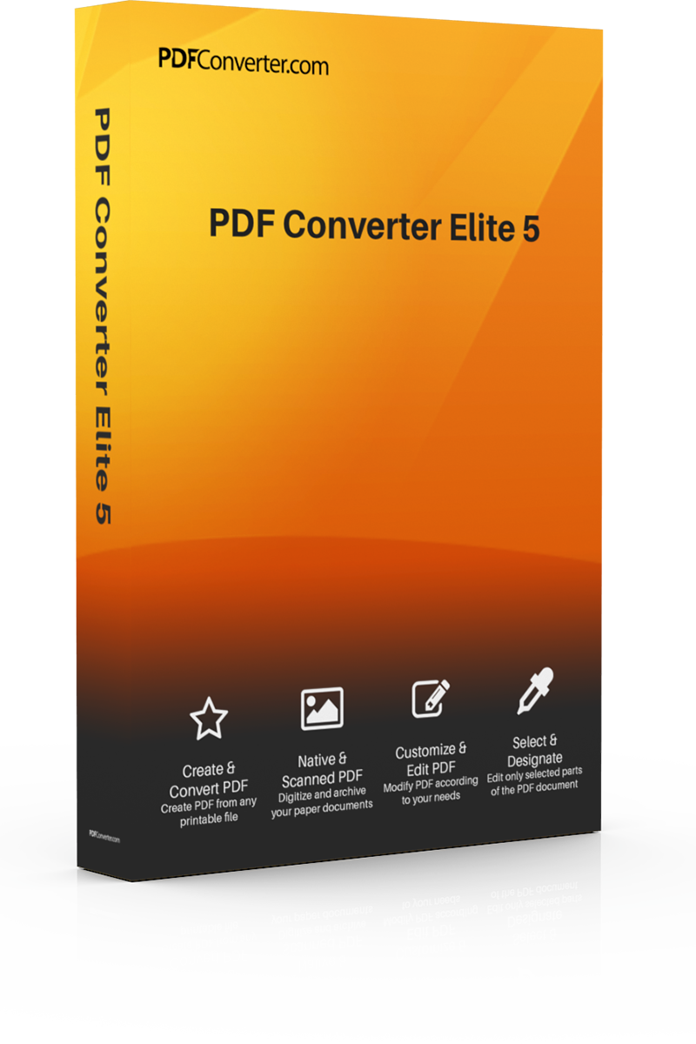

 | CONVERT SCANNED PDFs  PDF Converter Elite recognizes text in scanned files and export it to MS Office and other formats. Convert scanned PDF files to Word, Excel, CSV, PowerPoint, Publisher, Open Office, Image, HTML, AutoCAD. Extract text from PDF files and convert it into editable formats. Use scanned batch conversion to convert multiple scanned (image) files at once |  | merge and split pdf  Split PDF pages or merge different PDF files into one document. Combine whole PDF documents or join specific pages from different PDF files. Organize your PDF data by moving, deleting or switching pages to other documents.

custom PDF to Excel
Create personalized spreadsheets out of PDF files. Adjust and preview PDF tables before turning them into a Microsoft Excel or CSV. Personalize your charts, the structure and formatting of each document, so that your Excel output looks just the way you want it to. Move or delete rows and columns or add new ones.

